**P10.**

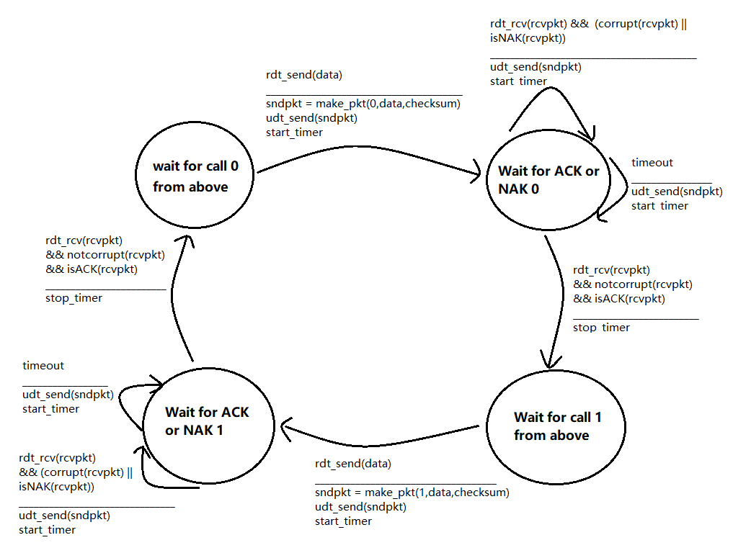

Although there is packet lose in this channel, there is also a maximum delay that is known. That means if the sender sends a packet, and this packet is not acknowledged within the maximum delay, then the sender could be sure that the packet is lost.

Let me illustrate why this works:

First the sender sends the packet, starts the timer, and enters into the “Wait for ACK or NAK 0” state.

Then if the timer counts more than the maximum delay, that means the prior sending packet is lost. This trigger the “timeout” event. So the sender would send the packet and refresh the timer again.

**P17**

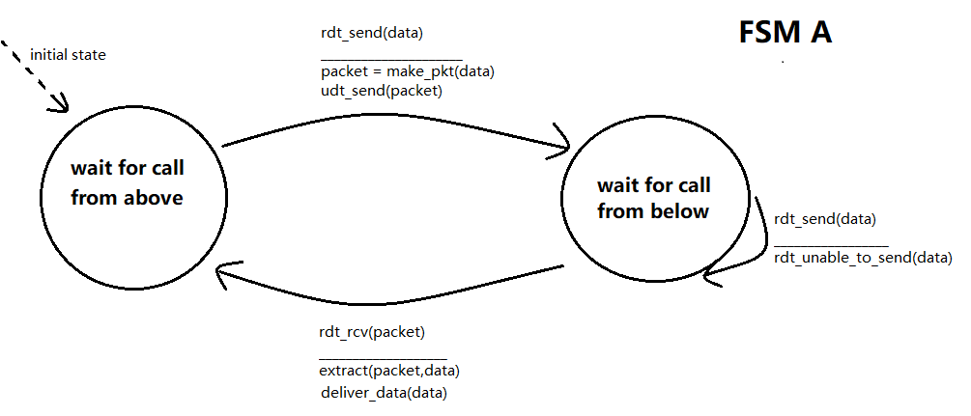

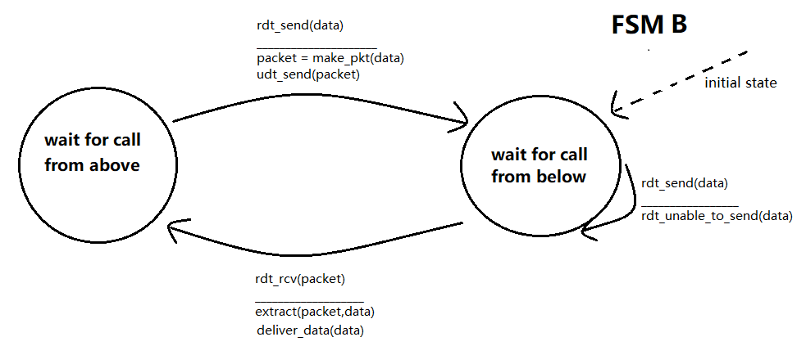

**P22**

1. The possible sets:

{k ,k+1,k+2,k+3} mod 1024

{k-1,k,k+1,k+2} mod 1024

{k-2,k-1,k,k+1} mod 1024

{k-3,k-2,k-1,k} mod 1024

{k-4,k-3,k-2,k-1} mod 1024

The receiver is expecting the segment that has a sequence number of k, that means the receiver has received the segments that have sequence number up to k-1. We can get some infers:

1. Segment with number k hasn’t been acknowledged.
2. Segment with number k-1 has been sent, may or may not has been acknowledged.
3. The ACK field in all possible messages may be:

{k-1} mod 1024 correspond to a (second set)

{k-2,k-1} mod 1024 correspond to a (third set)

{k-3,k-2,k-1} mod 1024 correspond to a (fourth set)

{k-4,k-3,k-2,k-1} mod 1024 correspond to a (fifth set)

The sets in **question a** represent the unacknowledged field and unused filed.

The element contained in these sets which is less than k is unacknowledged segment.